**LAB ASSIGNMENT-8.1**

**SK JAVID AMAN**

**2503A52L17**

**Test-Driven Development with AI – Generating and Working with Test Cases** **Lab Objectives**:

* To introduce students to test-driven development (TDD) using AI code generation tools.

Week4 - Monday

* To enable the generation of test cases before writing code implementations.
* To reinforce the importance of testing, validation, and error handling.
* To encourage writing clean and reliable code based on AI- generated test expectations.

Lab Outcomes (LOs):

After completing this lab, students will be able to:

* Use AI tools to write test cases for Python functions and classes.
* Implement functions based on test cases in a test-first development style.
* Use unittest or pytest to validate code correctness.
* Analyze the completeness and coverage of AI-generated tests.
* Compare AI-generated and manually written test cases for quality and logic

**Task Description #1** (Password Strength Validator – Apply AI in

Security Context)

PROMPT: generate at least 3 assert test cases for is_strong_password(password) and implement the validator function.

• Requirements:

o Password must have at least 8 characters.

o Must include uppercase, lowercase, digit, and special character.

o Must not contain spaces.

* Task: Apply AI to generate at least 3 assert test cases for is_strong_password(password) and implement the validator function.
* Requirements: o Password must have at least 8 characters. o Must

include uppercase, lowercase, digit, and special character. o Must not contain spaces. Example Assert Test Cases: assert is_strong_password("Abcd@123") == True assert is_strong_password("abcd123") == False assert is_strong_password("ABCD@1234") == True **Prompt for test case:**

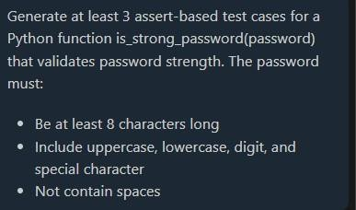

**Test case:**

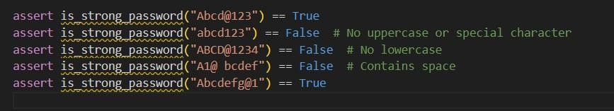

**Prompt for code:**

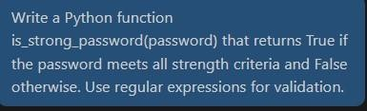

**Code:**

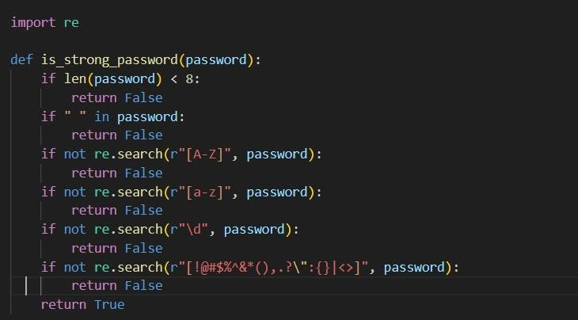

Expected Output #1:

* Password validation logic passing all AI-generated test cases.



**Task Description #2** (Number Classification with Loops –

Apply AI for

Edge Case Handling)

PROMPT:

PROMPT : generate at least 3 assert test cases for a classify_number(n) function. Implement using loops.

• Requirements:

o Classify numbers as Positive, Negative, or Zero.

o Handle invalid inputs like strings and None.

o Include boundary conditions (-1, 0, 1).

* Task: Use AI to generate at least 3 assert test cases for a classify_number(n) function. Implement using loops.
* Requirements: o Classify numbers as Positive, Negative, or Zero. o Handle invalid inputs like strings and None. o Include boundary conditions (-1, 0, 1).

Example Assert Test Cases: assert classify_number(10) == "Positive" assert classify_number(-5) == "Negative" assert classify_number(0) == "Zero" **prompt for test case:**

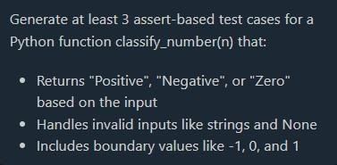

**Test case:**

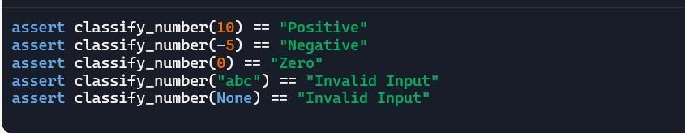

**Prompt for code:**

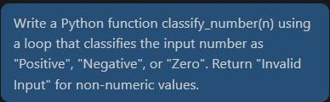

**Code:**

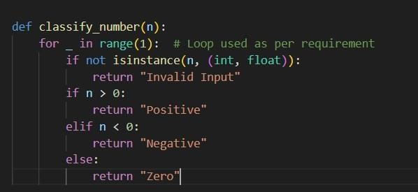

Expected Output #2:

* Classification logic passing all assert tests.



**Task Description #3** (Anagram Checker – Apply AI for String

Analysis)

PROMPT : Task: Use AI to generate at least 3 assert test cases for is_anagram(str1, str2) and implement the function.

• Requirements:

o Ignore case, spaces, and punctuation.

o Handle edge cases (empty strings, identical words).

• Function correctly identifying anagrams and passing all AI-generated tests.

* Task: Use AI to generate at least 3 assert test cases for is_anagram(str1, str2) and implement the function.
* Requirements:

o Ignore case, spaces, and punctuation. o Handle edge cases (empty strings, identical words).

Example Assert Test Cases: assert is_anagram("listen", "silent") == True assert

is_anagram("hello", "world") == False assert is_anagram("Dormitory", "Dirty Room") == True

**Prompt for test case:**

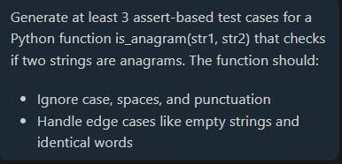

**Test case:**

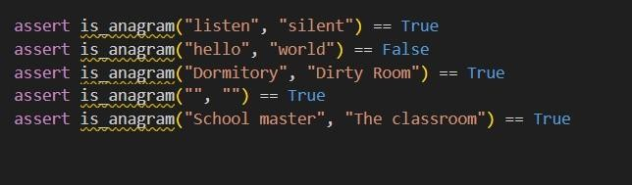

**Prompt for code:**

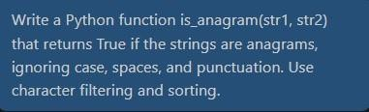

**Code:**

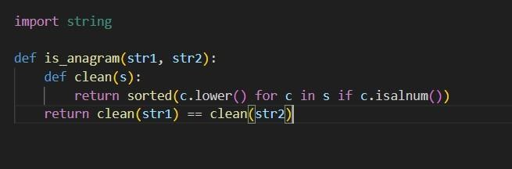

Expected Output #3:

* Function correctly identifying anagrams and passing all AI- generated tests.



**Task Description #4** (Inventory Class – Apply AI to Simulate

Real-

World Inventory System)

PROMPT:generate at least 3 assert-based tests for an Inventory class with stock management.

• Methods:

o add_item(name, quantity)

o remove_item(name, quantity)

o get_stock(name)

* Task: Ask AI to generate at least 3 assert-based tests for an Inventory class with stock management.
* Methods:

o add_item(name, quantity) o remove_item(name, quantity) o get_stock(name) Example Assert Test Cases: inv = Inventory()

inv.add_item("Pen", 10) assert inv.get_stock("Pen") == 10 inv.remove_item("Pen", 5) assert inv.get_stock("Pen") == 5 inv.add_item("Book", 3) assert inv.get_stock("Book") == 3 **Prompt for test case:**

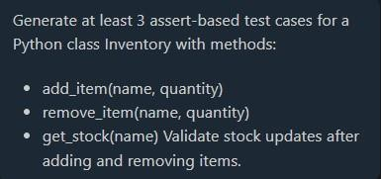

**Test case:**

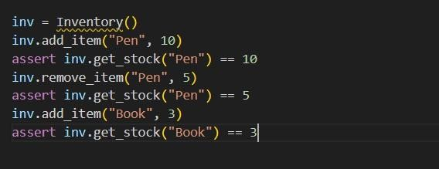

**Prompt for code:**

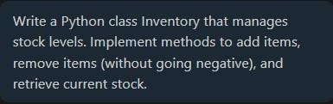

**Code:**

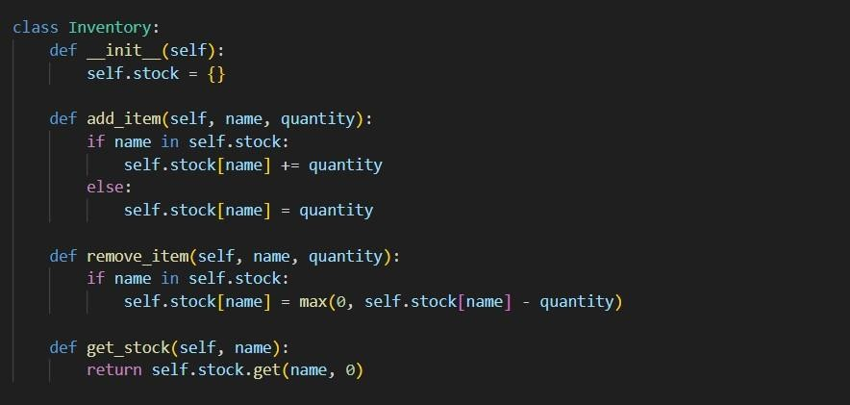

Expected Output #4:

* Fully functional class passing all assertions.



**Task Description #5** (Date Validation & Formatting – Apply AI for

Data Validation)

PROMPT: generate at least 3 assert test cases for validate_and_format_date(date_str) to check and convert dates.

• Requirements:

o Validate "MM/DD/YYYY" format.

o Handle invalid dates.

o Convert valid dates to "YYYY-MM-DD".

* Task: Use AI to generate at least 3 assert test cases for validate_and_format_date(date_str) to check and convert dates.
* Requirements: o Validate "MM/DD/YYYY" format. o Handle invalid dates. o Convert valid dates to "YYYY-MM-DD".

Example Assert Test Cases: assert validate_and_format_date("10/15/2023") == "2023-10-15" assert validate_and_format_date("02/30/2023") == "Invalid Date" assert validate_and_format_date("01/01/2024") == "2024-01-01" **Prompt for test case:**

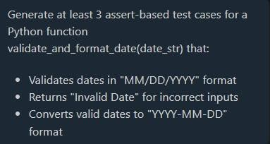

**Test case:**

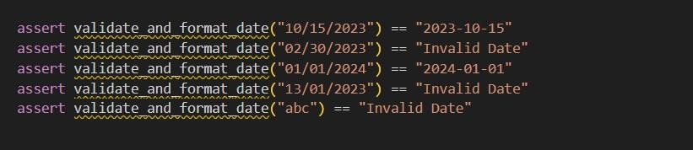

**Prompt for code:**

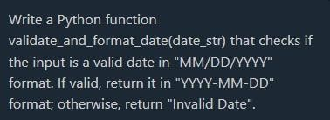

**Code:**

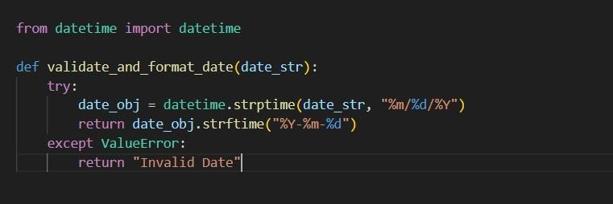

Expected Output #5:

* Function passes all AI-generated assertions and handles edge cases.



**Final summary:**

